Project: University Society Website

***Applications Of Information & Communication Technology***

*PRO..Ashir Kamal (Bunny)*

**Meet The Develpers :**

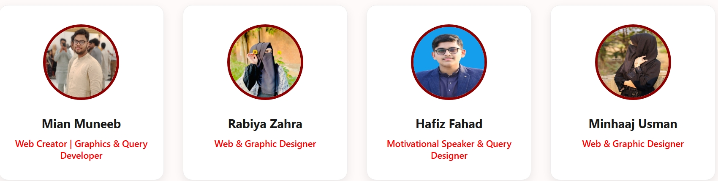

2025-CS-482

2025-CS-504

2025-CS-532

2025-CS-526

https://github.com/Minhaaj-usman

https://github.com/HI-Tech-39f

https://github.com/Hafiz-Fahad-Zubair

https://github.com/Rabiya-zahra56

https://www.linkedin.com/in/minhaj-usman-03526b381?

https://www.linkedin.com/in/hafiz -fahad-zubair-480021389

https://www.linkedin.com/in/rabiya-zahra03869b387?

https://www.linkedin.com/in/muneeb-fayaz-05bba8376?trk=people-search-result

**Blood Donation Management System**

**The Hero Pulse**

‘One Drop,One Life’

**Introduction:**

**The Hero Pulse** is a digital initiative developed for a university society. The platform aims to connect blood donors with individuals in urgent need of blood. By digitizing the donation process, the website ensures quick access to life-saving resources, manages donor databases, and provides information about upcoming blood camps.

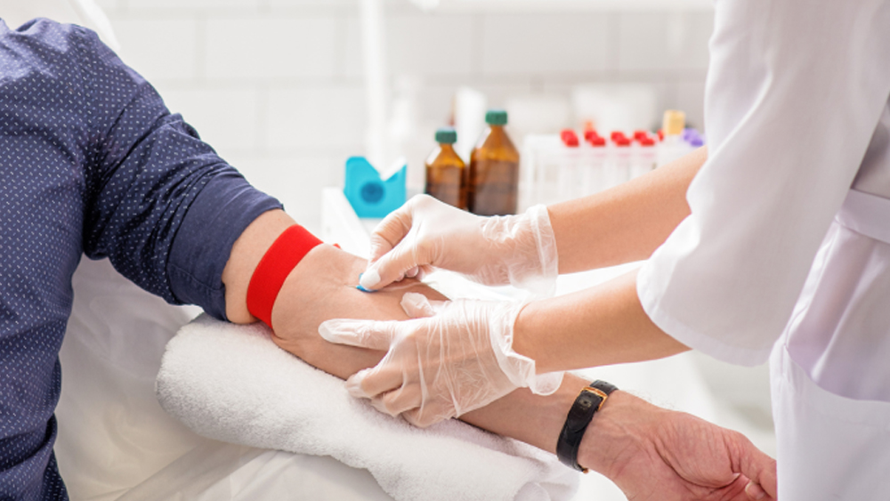

By integrating dynamic web modules like Blood Camps and Donor Services, the platform provides a seamless interface for coordinating life-saving donations.

**Project Objectives:**

The primary objective of **The Hero Pulse** is to create a technology-driven ecosystem that empowers our university society to save lives. Specifically, the project aims:

* **To Establish a Digital Donor Network:** To replace manual record-keeping with a sophisticated digital registry, allowing for the instant categorization of donors by blood group and geographical location.
* **To Streamline Emergency Response:** To facilitate receptors and hospitals in raising urgent requests, ensuring that the required quantity (bottles/units) of blood is matched with compatible donors in real-time.
* **To Enhance Community Accessibility:** To provide a centralized platform where students and the public can easily access information about upcoming blood donation camps and community health events.
* **To Foster Public Awareness:** To serve as an educational hub that informs the community about blood compatibility, the health benefits of donation, and the critical impact of every single unit donated.
* **To Optimize Data Accuracy:** To ensure data integrity through a structured SQL backend, allowing the society to maintain precise records of donor history and receptor needs.



**Tools Used:**

* **Frontend:** HTML, CSS (for a responsive and user-friendly interface).
* **Backend:** SQL (Structured Query Language) for database management.
* **Design Tools:**  Canva (for creating the official logo, posters, and banners).
* **Documentation:**  Microsoft Word.

** **

** **

**Website Structure and Modules:**

Based on the website's source code, the following pages and modules have been implemented:

**Home Page**: This is the central landing hub of **The Hero Pulse**. It introduces the society’s core mission of saving lives through blood donation. The page features prominent call-to-action buttons like "Donate Now" and "Request Blood," ensuring that users can quickly navigate to their required service during emergencies.

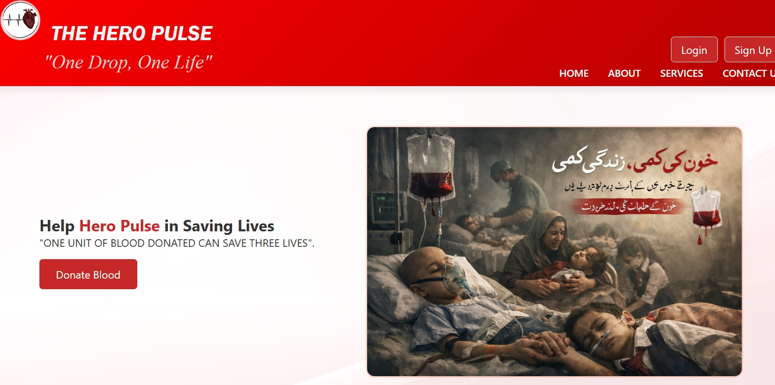

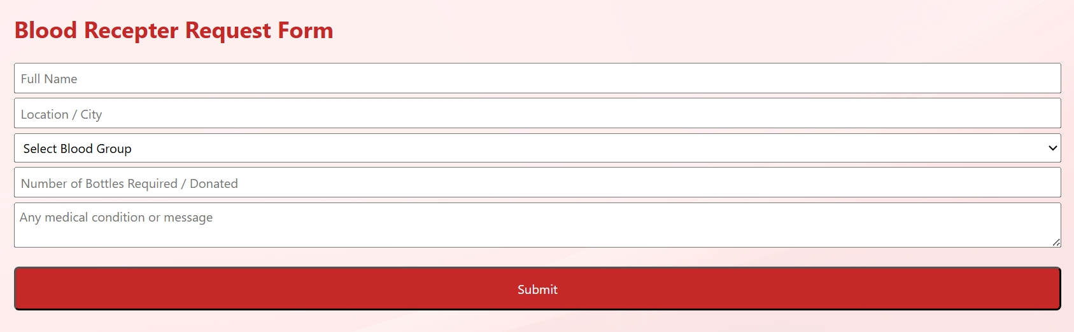

**About Us**:

This page provides an in-depth look into the university society behind the project. It outlines our vision, the history of our initiatives, and the dedicated team working to manage the blood supply chain. It helps build trust and transparency with the community

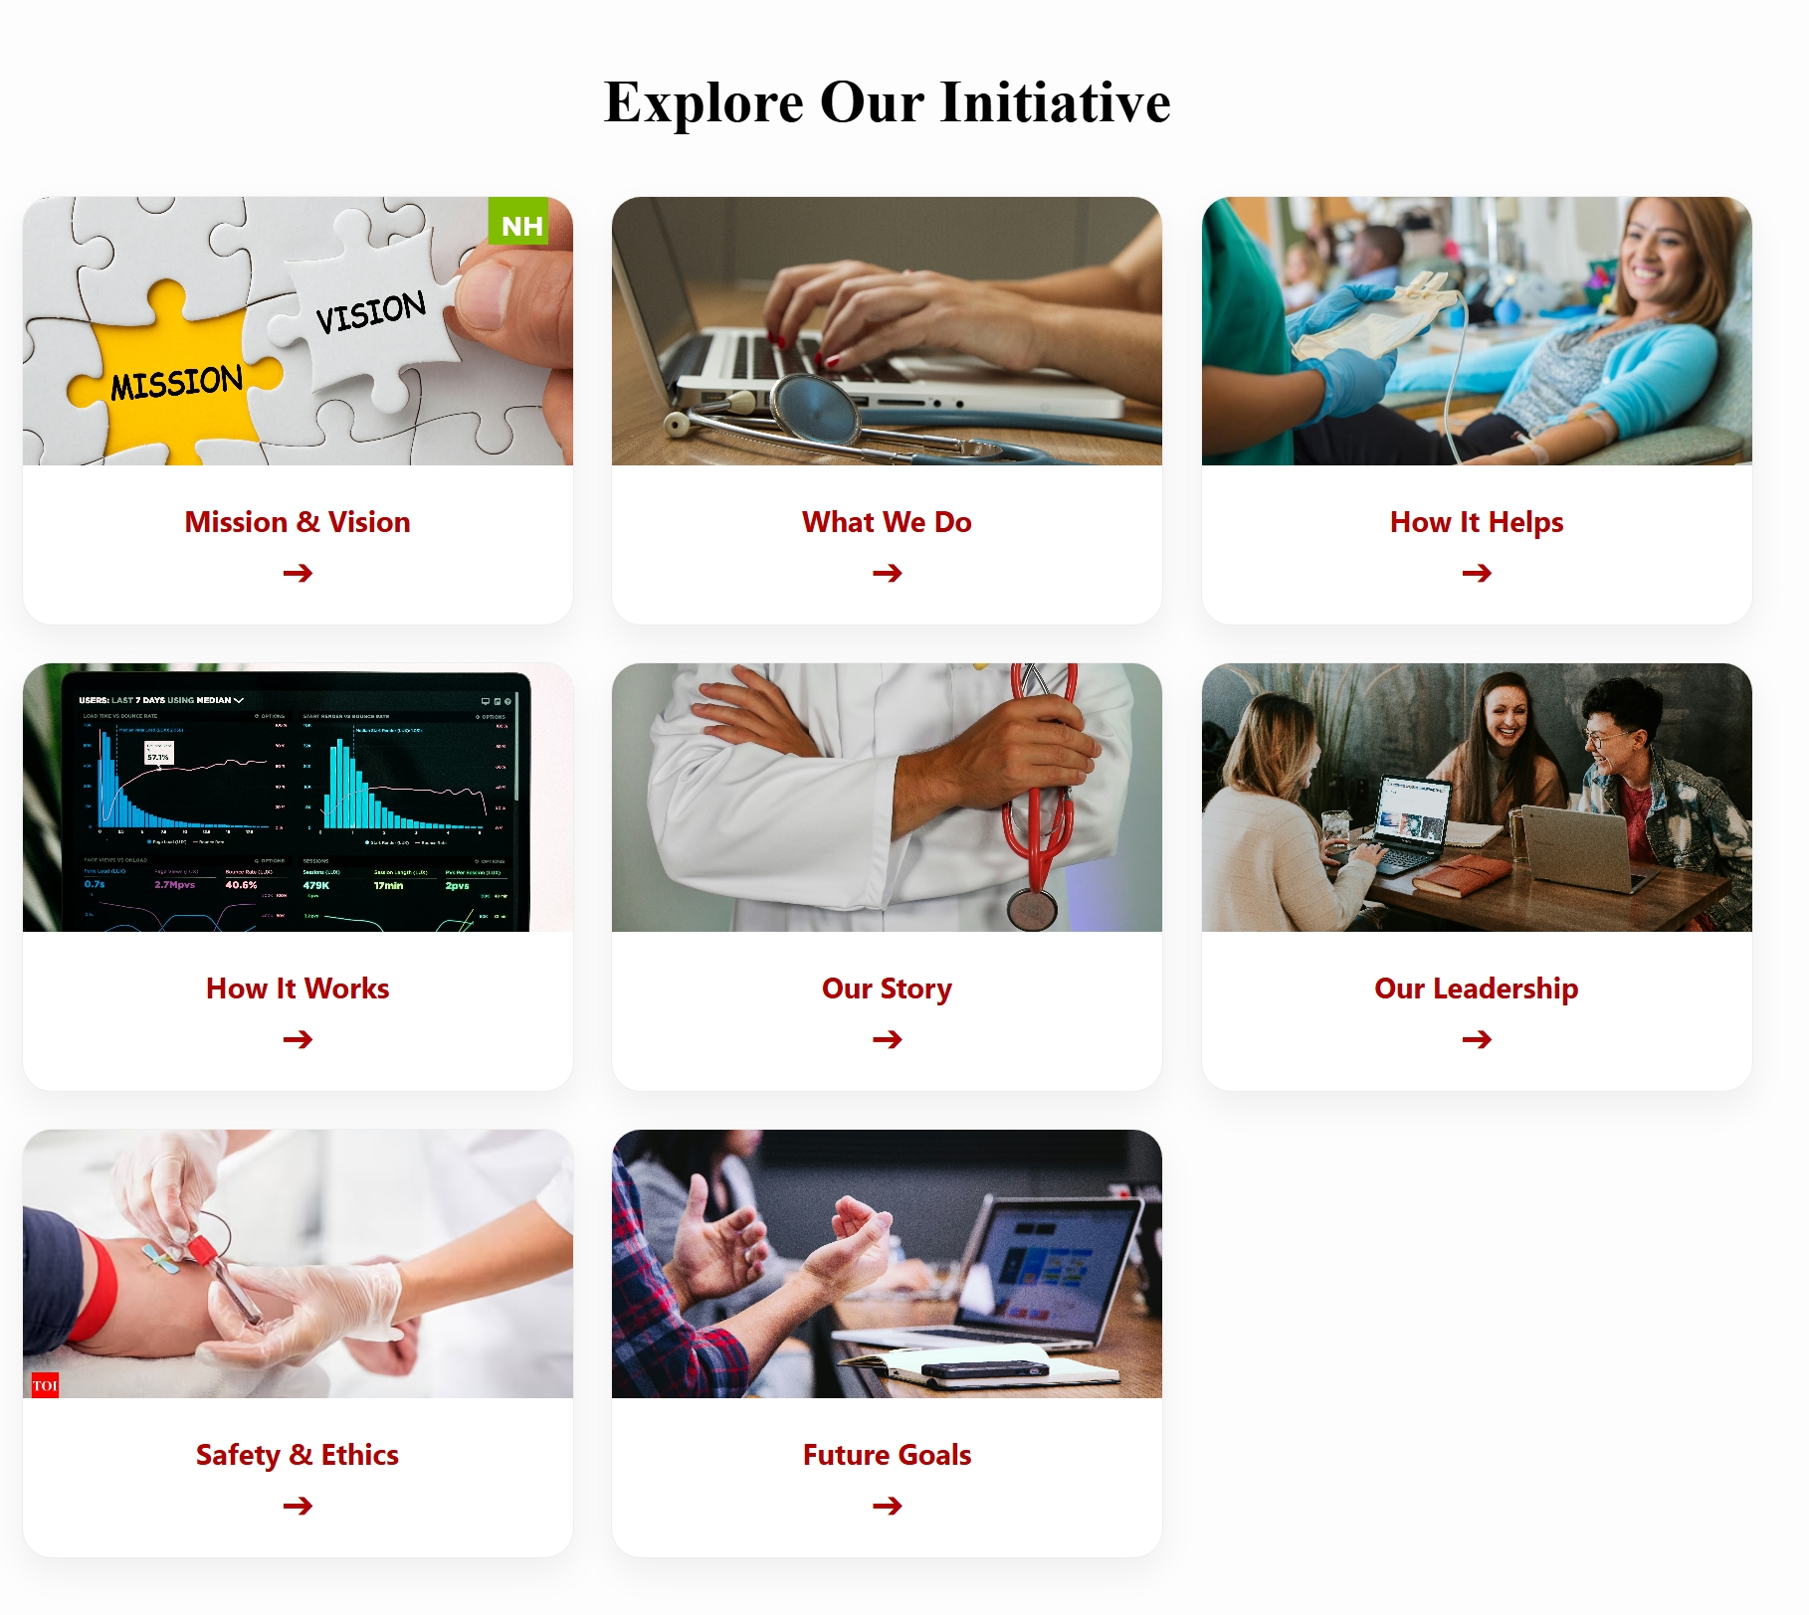

**Services**:

The Services page details the technical and medical support provided by the platform. This includes blood group testing coordination, emergency 24/7 blood request matching, and a direct link between the society’s database and local hospitals to ensure swift delivery.

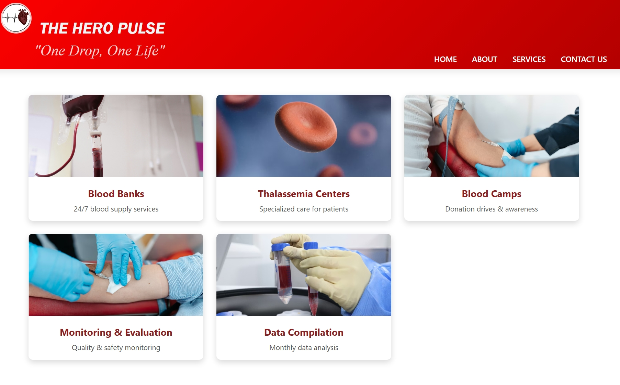

**Contact Us**:

The Contact page provides a bridge for direct communication. It includes a functional form where users can send specific queries, report technical issues, or ask for urgent help. It also lists the society’s official social media handles and physical office location. 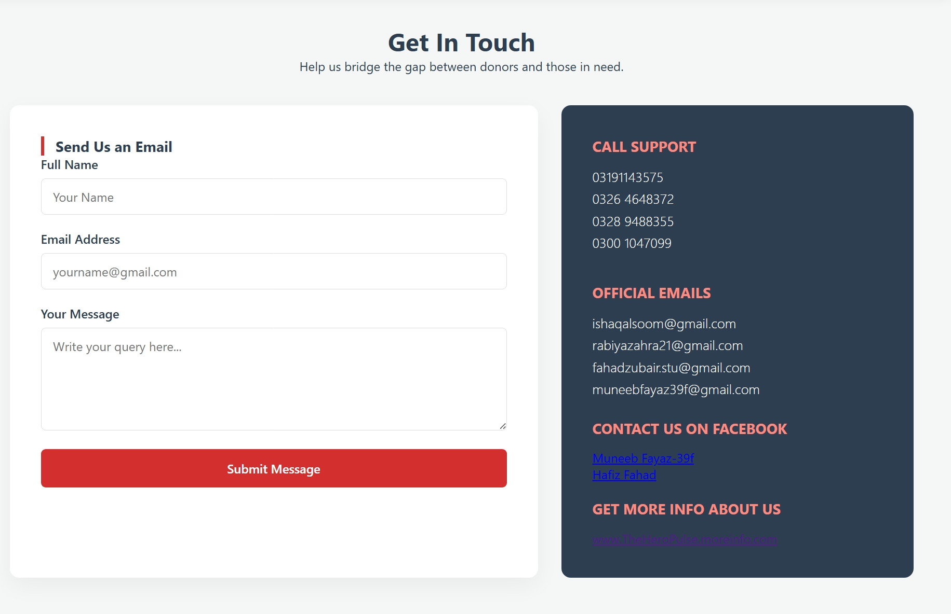**Graphics:**

**BANNER**

**LOGO**

**Poster**

**DATA BASE TABLES:**

**SQL Donors table:**

|  |  |  |  |  |  |  |
| --- | --- | --- | --- | --- | --- | --- |
| **donor-id** | **donorname** | **donorage** | **bloodgroup** | **location** | **contact** | **Email** |
| 1 | shafiqe zahoor | 45 | A+ | lahore | 0300-2342435 | shfiqe zahoore@gmail.com |
| 2 | ali ahmad | 47 | A- | samundri | 0300-23123435 | ali ahmad@gmail.com |
| 3 | abdullah abid | 49 | Ab+ | faisalabad | 0331-2342435 | abdullahabid@gmail.com |
| 4 | saim sultan | 38 | B- | qasoor | 0331-4532135 | saim sultan@gmail.com |
| 5 | ayesha ansir | 42 | B+ | multan | 0321-1232435 | ayeshaansir@gmail.com |
| 6 | mushtaq yousuf | 52 | AB- | wahari | 0312-8755435 | mushtaqyousuf@gmail.com |
| 7 | laiba amjad | 41 | o+ | ferozpur | 0300-2341234 | laibaamjad@gmail.com |
| 8 | muneeb fayaz | 35 | AB+ | lahore | 0300-1234435 | muneebfayaz39f@gmail.com |
| 9 | esha amjad | 53 | o- | layyah | 0300-1564435 | eshaamjad@gmail.com |
| 10 | nayab saleem | 36 | AB- | sahiwal | 0300-6754435 | nayabsaleem@gmail.com |

**SQL Receptors table:**

|  |  |  |  |  |  |
| --- | --- | --- | --- | --- | --- |
| **receptorID** | **receptorname** | **req_bloodgroup** | **location** | **req_numberofbottles** | **contact** |
| 1100 | insha javeed | AB- | lahore dera gujra | 2 | 03054696896 |
| 1200 | kalsoom amir | B- | saaki bhalwaal | 1.3 | 03052316896 |
| 1300 | adil mustaaq | o+ | faislabaad ganta kaar | 3.25 | 03054685696 |
| 1400 | cr chaudhary | A- | chuburji lahore | 0.5 | 03054690012 |
| 1500 | Zoha Mukkarm | B- | dera gaazi khan peshawar | 5.28 | 03054696106 |
| 1600 | rabiya zahra | o- | muree hazaara | 0.75 | 03230546966 |
| 1700 | muhammad ahmed | AB+ | lahore jallo pind | 1.03 | 03054611296 |
| 1800 | osman adnan | B- | makhion pura hunza | 4.5 | 03054887799 |
| 1900 | hafiz fahad | B+ | rorri tower lahore | 4.95 | 03054655076 |
| 2000 | mian muneeb | A+ | kutab minaar | 7.96 | 03054656936 |
| 2100 | dalaal chaudhary | o+ | hero shimma saki nagar islamabad | 1.2 | 03074352276 |

**SQL Donors and Receptors table :**

|  |  |  |  |  |  |  |  |  |  |  |  |  |
| --- | --- | --- | --- | --- | --- | --- | --- | --- | --- | --- | --- | --- |
| **receptorID** | **receptorname** | **req_bloodgroup** | **receptor_location** | **req_numberofbottles** | **receptor_contact** | **donorsID** | **donorname** | **donorage** | **donor_bloodgroup** | **donor_location** | **donor_contact** | **Email** |
| 1100 | insha javeed | AB- | lahore dera gujra | 2 | 03054696896 | 10 | nayab saleem | 36 | AB- | sahiwal | 0300-6754435 | nayabsaleem@gmail.com |
| 1100 | insha javeed | AB- | lahore dera gujra | 2 | 03054696896 | 9 | esha amjad | 53 | o- | layyah | 0300-1564435 | eshaamjad@gmail.com |
| 1100 | insha javeed | AB- | lahore dera gujra | 2 | 03054696896 | 6 | mushtaq yousuf | 52 | AB- | wahari | 0312-8755435 | mushtaqyousuf@gmail.com |
| 1100 | insha javeed | AB- | lahore dera gujra | 2 | 03054696896 | 4 | saim sultan | 38 | B- | qasoor | 0331-4532135 | saim sultan@gmail.com |
| 1100 | insha javeed | AB- | lahore dera gujra | 2 | 03054696896 | 2 | ali ahmad | 47 | A- | samundri | 0300-23123435 | ali ahmad@gmail.com |
| 1200 | kalsoom amir | B- | saaki bhalwaal | 1.3 | 03052316896 | 9 | esha amjad | 53 | o- | layyah | 0300-1564435 | eshaamjad@gmail.com |
| 1200 | kalsoom amir | B- | saaki bhalwaal | 1.3 | 03052316896 | 4 | saim sultan | 38 | B- | qasoor | 0331-4532135 | saim sultan@gmail.com |
| 1300 | adil mustaaq | o+ | faislabaad ganta kaar | 3.25 | 03054685696 | 9 | esha amjad | 53 | o- | layyah | 0300-1564435 | eshaamjad@gmail.com |
| 1300 | adil mustaaq | o+ | faislabaad ganta kaar | 3.25 | 03054685696 | 7 | laiba amjad | 41 | o+ | ferozpur | 0300-2341234 | laibaamjad@gmail.com |
| 1400 | cr chaudhary | A- | chuburji lahore | 0.5 | 03054690012 | 9 | esha amjad | 53 | o- | layyah | 0300-1564435 | eshaamjad@gmail.com |
| 1400 | cr chaudhary | A- | chuburji lahore | 0.5 | 03054690012 | 2 | ali ahmad | 47 | A- | samundri | 0300-23123435 | ali ahmad@gmail.com |
| 1500 | zoha mukkarm | B- | dera gaazi khan peshawar | 5.28 | 03054696106 | 9 | esha amjad | 53 | o- | layyah | 0300-1564435 | eshaamjad@gmail.com |
| 1500 | zoha mukkarm | B- | dera gaazi khan peshawar | 5.28 | 03054696106 | 4 | saim sultan | 38 | B- | qasoor | 0331-4532135 | saim sultan@gmail.com |
| 1600 | rabiya zahra | o- | muree hazaara | 0.75 | 03230546966 | 9 | esha amjad | 53 | o- | layyah | 0300-1564435 | eshaamjad@gmail.com |
| 1700 | muhammad ahmed | AB+ | lahore jallo pind | 1.03 | 03054611296 | 10 | nayab saleem | 36 | AB- | sahiwal | 0300-6754435 | nayabsaleem@gmail.com |
| 1700 | muhammad ahmed | AB+ | lahore jallo pind | 1.03 | 03054611296 | 9 | esha amjad | 53 | o- | layyah | 0300-1564435 | eshaamjad@gmail.com |
| 1700 | muhammad ahmed | AB+ | lahore jallo pind | 1.03 | 03054611296 | 8 | muneeb fayaz | 35 | AB+ | lahore | 0300-1234435 | muneebfayaz39f@gmail.com |
| 1700 | muhammad ahmed | AB+ | lahore jallo pind | 1.03 | 03054611296 | 7 | laiba amjad | 41 | o+ | ferozpur | 0300-2341234 | laibaamjad@gmail.com |
| 1700 | muhammad ahmed | AB+ | lahore jallo pind | 1.03 | 03054611296 | 6 | mushtaq yousuf | 52 | AB- | wahari | 0312-8755435 | mushtaqyousuf@gmail.com |
| 1700 | muhammad ahmed | AB+ | lahore jallo pind | 1.03 | 03054611296 | 5 | ayesha ansir | 42 | B+ | multan | 0321-1232435 | ayeshaansir@gmail.com |
| 1700 | muhammad ahmed | AB+ | lahore jallo pind | 1.03 | 03054611296 | 4 | saim sultan | 38 | B- | qasoor | 0331-4532135 | saim sultan@gmail.com |
| 1700 | muhammad ahmed | AB+ | lahore jallo pind | 1.03 | 03054611296 | 3 | abdullah abid | 49 | Ab+ | faisalabad | 0331-2342435 | abdullahabid@gmail.com |
| 1700 | muhammad ahmed | AB+ | lahore jallo pind | 1.03 | 03054611296 | 2 | ali ahmad | 47 | A- | samundri | 0300-23123435 | ali ahmad@gmail.com |
| 1700 | muhammad ahmed | AB+ | lahore jallo pind | 1.03 | 03054611296 | 1 | shafiqe zahoor | 45 | A+ | lahore | 0300-2342435 | shfiqe zahoore@gmail.com |
| 1800 | osman adnan | B- | makhion pura hunza | 4.5 | 03054887799 | 9 | esha amjad | 53 | o- | layyah | 0300-1564435 | eshaamjad@gmail.com |
| 1800 | osman adnan | B- | makhion pura hunza | 4.5 | 03054887799 | 4 | saim sultan | 38 | B- | qasoor | 0331-4532135 | saim sultan@gmail.com |
| 1900 | hafiz fahad | B+ | rorri tower lahore | 4.95 | 03054655076 | 9 | esha amjad | 53 | o- | layyah | 0300-1564435 | eshaamjad@gmail.com |
| 1900 | hafiz fahad | B+ | rorri tower lahore | 4.95 | 03054655076 | 7 | laiba amjad | 41 | o+ | ferozpur | 0300-2341234 | laibaamjad@gmail.com |
| 1900 | hafiz fahad | B+ | rorri tower lahore | 4.95 | 03054655076 | 5 | ayesha ansir | 42 | B+ | multan | 0321-1232435 | ayeshaansir@gmail.com |
| 1900 | hafiz fahad | B+ | rorri tower lahore | 4.95 | 03054655076 | 4 | saim sultan | 38 | B- | qasoor | 0331-4532135 | saim sultan@gmail.com |
| 2000 | mian muneeb | A+ | kutab minaar | 7.96 | 03054656936 | 9 | esha amjad | 53 | o- | layyah | 0300-1564435 | eshaamjad@gmail.com |
| 2000 | mian muneeb | A+ | kutab minaar | 7.96 | 03054656936 | 7 | laiba amjad | 41 | o+ | ferozpur | 0300-2341234 | laibaamjad@gmail.com |
| 2000 | mian muneeb | A+ | kutab minaar | 7.96 | 03054656936 | 2 | ali ahmad | 47 | A- | samundri | 0300-23123435 | ali ahmad@gmail.com |
| 2000 | mian muneeb | A+ | kutab minaar | 7.96 | 03054656936 | 1 | shafiqe zahoor | 45 | A+ | lahore | 0300-2342435 | shfiqe zahoore@gmail.com |
| 2100 | dalaal chaudhary | o+ | hero shimma saki nagar islamabad | 1.2 | 03074352276 | 9 | esha amjad | 53 | o- | layyah | 0300-1564435 | eshaamjad@gmail.com |
| 2100 | dalaal chaudhary | o+ | hero shimma saki nagar islamabad | 1.2 | 03074352276 | 7 | laiba amjad | 41 | o+ | ferozpur | 0300-2341234 | laibaamjad@gmail.com |
| 2200 | Fatima noor | A+ | alrehmaan garden lahore | 6.3 | 03246092598 | 9 | esha amjad | 53 | o- | layyah | 0300-1564435 | eshaamjad@gmail.com |
| 2200 | Fatima noor | A+ | alrehmaan garden lahore | 6.3 | 03246092598 | 7 | laiba amjad | 41 | o+ | ferozpur | 0300-2341234 | laibaamjad@gmail.com |
| 2200 | Fatima noor | A+ | alrehmaan garden lahore | 6.3 | 03246092598 | 2 | ali ahmad | 47 | A- | samundri | 0300-23123435 | ali ahmad@gmail.com |
| 2200 | Fatima noor | A+ | alrehmaan garden lahore | 6.3 | 03246092598 | 1 | shafiqe zahoor | 45 | A+ | lahore | 0300-2342435 | shfiqe zahoore@gmail.com |

**Compatibility of Blood Group:**

|  |  |
| --- | --- |
| **req_group** | **donor_group** |
| O- | O- |
| O+ | O- |
| O+ | O+ |
| A- | O- |
| A- | A- |
| A+ | O- |
| A+ | O+ |
| A+ | A- |
| A+ | A+ |
| B- | B- |
| B- | O- |
| B+ | B- |
| B+ | B+ |
| B+ | O+ |
| B+ | O- |
| AB+ | O- |
| AB+ | O+ |
| AB+ | A- |
| AB+ | A+ |
| AB+ | B- |
| AB+ | B+ |
| AB+ | AB- |
| AB+ | AB+ |
| AB- | AB- |
| AB- | O- |
| AB- | A- |
| AB- | B- |

|  |  |  |
| --- | --- | --- |
| | **Total_no_of_Donors** | | --- | | 10 | |

|  |  |  |  |
| --- | --- | --- | --- |
| | **Total_no_of_Receptors** | | --- | | 12 | |  | |

**SQL QURIES:**

**SCHEMA SQL:**

**CREATE TABLE donors(**

**donorsID INT PRIMARY KEY,**

**donorname VARCHAR(50),**

**donorage INT ,**

**bloodgroup VARCHAR(20),**

**location VARCHAR(50),**

**contact VARCHAR(50),**

**Email VARCHAR(50)**

**);**

**CREATE TABLE receptors(**

**receptorID INT PRIMARY KEY,**

**receptorname VARCHAR(50),**

**req_bloodgroup VARCHAR(20),**

**location VARCHAR(50),**

**req_numberofbottles FLOAT,**

**contact VARCHAR(20)**

**);**

**CREATE TABLE compatibility (**

**req_group VARCHAR(10),**

**donor_group VARCHAR(10)**

**);**

**QURIES SQL:**

**INSERT INTO donors(**

**donorsID,donorname,donorage,bloodgroup,location,contact,Email**

**)VALUES**

**(001,'shafiqe zahoor',45,'A+','lahore','0300-2342435','shfiqe zahoore@gmail.com'),**

**(002,'ali ahmad',47,'A-','samundri','0300-23123435','ali ahmad@gmail.com'),**

**(003,'abdullah abid',49,'Ab+','faisalabad','0331-2342435','abdullahabid@gmail.com'),**

**(004,'saim sultan',38,'B-','qasoor','0331-4532135','saim sultan@gmail.com'),**

**(005,'ayesha ansir',42,'B+','multan','0321-1232435','ayeshaansir@gmail.com'),**

**(006,'mushtaq yousuf',52,'AB-','wahari','0312-8755435','mushtaqyousuf@gmail.com'),**

**(007,'laiba amjad',41,'o+','ferozpur','0300-2341234','laibaamjad@gmail.com'),**

**(008,'muneeb fayaz',35,'AB+','lahore','0300-1234435','muneebfayaz39f@gmail.com'),**

**(009,'esha amjad',53,'o-','layyah','0300-1564435','eshaamjad@gmail.com'),**

**(010,'nayab saleem',36,'AB-','sahiwal','0300-6754435','nayabsaleem@gmail.com');**

**INSERT INTO receptors(receptorID,receptorname,req_bloodgroup,location,req_numberofbottles,contact)VALUES**

**(1100,'insha javeed','AB-','lahore dera gujra',2,'03054696896'),**

**(1200,'kalsoom amir','B-','saaki bhalwaal',1.3,'03052316896'),**

**(1300,'adil mustaaq','o+','faislabaad ganta kaar',3.25,'03054685696'),**

**(1400,'cr chaudhary','A-','chuburji lahore',0.5,'03054690012'),**

**(1500,'zoha mukkarm','B-','dera gaazi khan peshawar',5.28,'03054696106'),**

**(1600,'rabiya zahra','o-','muree hazaara',0.75,'03230546966'),**

**(1700,'muhammad ahmed','AB+','lahore jallo pind',1.03,'03054611296'),**

**(1800,'osman adnan','B-','makhion pura hunza',4.5,'03054887799'),**

**(1900,'hafiz fahad','B+','rorri tower lahore',4.95,'03054655076'),**

**(2000,'mian muneeb','A+','kutab minaar',7.96,'03054656936'),**

**(2100,'dalaal chaudhary','o+','hero shimma saki nagar islamabad',1.20,'03074352276'),**

**(2200,'Fatima noor','A+','alrehmaan garden lahore',6.3,'03246092598');**

**INSERT INTO compatibility (req_group, donor_group) VALUES**

**('O-','O-'),**

**('O+','O-'),('O+','O+'),**

**('A-','O-'),('A-','A-'),**

**('A+','O-'),('A+','O+'),('A+','A-'),('A+','A+'),**

**('B-','B-'),('B-','O-'),**

**('B+','B-'),('B+','B+'),('B+','O+'),('B+','O-'),**

**('AB+','O-'),('AB+','O+'),('AB+','A-'),('AB+','A+'),('AB+','B-'),('AB+','B+'),('AB+','AB-'),('AB+','AB+'),**

**('AB-','AB-'),('AB-','O-'),('AB-','A-'),('AB-','B-');**

**SELECT * FROM donors;**

**SELECT * FROM receptors;**

**SELECT**

**r.receptorID,**

**r.receptorname,**

**r.req_bloodgroup,**

**r.location AS receptor_location,**

**r.req_numberofbottles,**

**r.contact AS receptor_contact,**

**d.donorsID,**

**d.donorname,**

**d.donorage,**

**d.bloodgroup AS donor_bloodgroup,**

**d.location AS donor_location,**

**d.contact AS donor_contact,**

**d.Email**

**FROM receptors r**

**JOIN donors d**

**ON (**

**-- normalize both sides**

**(**

**UPPER(TRIM(r.req_bloodgroup)) = 'O-' AND UPPER(TRIM(d.bloodgroup)) IN ('O-')**

**)**

**OR (**

**UPPER(TRIM(r.req_bloodgroup)) = 'O+' AND UPPER(TRIM(d.bloodgroup)) IN ('O-','O+')**

**)**

**OR (**

**UPPER(TRIM(r.req_bloodgroup)) = 'A-' AND UPPER(TRIM(d.bloodgroup)) IN ('O-','A-','O','A')**

**)**

**OR (**

**UPPER(TRIM(r.req_bloodgroup)) = 'A+' AND UPPER(TRIM(d.bloodgroup)) IN ('O-','O+','A-','A+','O','A')**

**)**

**OR (**

**UPPER(TRIM(r.req_bloodgroup)) = 'B-' AND UPPER(TRIM(d.bloodgroup)) IN ('O-','B-','O','B')**

**)**

**OR (**

**UPPER(TRIM(r.req_bloodgroup)) = 'B+' AND UPPER(TRIM(d.bloodgroup)) IN ('O-','O+','B-','B+','O','B')**

**)**

**OR (**

**UPPER(TRIM(r.req_bloodgroup)) = 'AB-' AND UPPER(TRIM(d.bloodgroup)) IN ('O-','A-','B-','AB-','O','A','B','AB')**

**)**

**OR (**

**UPPER(TRIM(r.req_bloodgroup)) = 'AB+' AND UPPER(TRIM(d.bloodgroup)) IN ('O-','O+','A-','A+','B-','B+','AB-','AB+','O','A','B','AB')**

**)**

**);**

**SELECT * FROM compatibility;**

**SELECT COUNT(*) AS Total_no_of_Donors FROM donors;**

**SELECT COUNT(*) AS Total_no_of_Receptors FROM receptors;**

Conclusion

* In conclusion, The Hero Pulse is a successful project created to help our university society manage blood donations easily. By using this website, we have moved from old paper records to a fast and modern digital system.
* The project shows how a simple website can solve a big problem. The frontend is easy for everyone to use, while the backend SQL database keeps all the donor and receptor information safe and organized. Features like the Blood Camps page and the Emergency Forms make it very quick to find help when someone needs blood urgently.
* Ultimately, this project is not just about coding; it is about helping people. The Hero Pulse makes it easier for students and the public to donate blood and save lives. It is a powerful tool that will help our society grow and serve the community better in the future.